02/28/2026, Menlo Church Worship, Legacy (last week)

https://www.youtube.com/live/EYP2zTQK3QE?si=L1iGmo0BEvQpljhN

“I Am With You in the Desert | I Am: The God Who Gets Close,” Phil EuBank, Lead Pastor

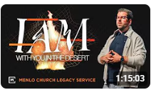

Introduction:

12:00/1:15:02

 

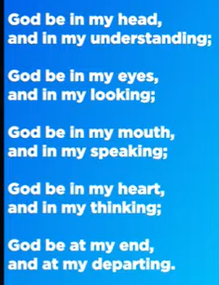

19:00/1:15:02

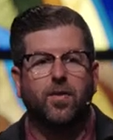 

Phil EuBank, Lead Pastor

We are in the new series of “I Am: Arrival” Series.

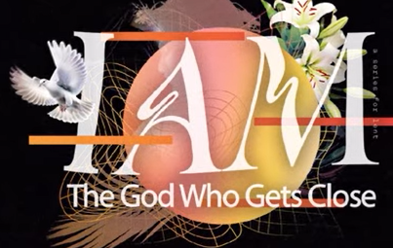

The God Who Gets Close

The concept of "The God Who Gets Close" highlights a deity that is intimately involved in human life, breaking barriers to foster a personal relationship rather than remaining distant. Central themes include the promise that drawing near to God initiates reciprocal closeness, God's pursuit of humanity through vulnerable love, and His presence with the brokenhearted.

* **Biblical Promise:** James 4:8 encourages believers to "Draw near to God and He will draw near to you".
* **Vulnerable Love:** The incarnation (Jesus as a baby) is seen as God removing barriers to achieve intimate, tender, and accessible connection.
* **Active Presence:** God is described as being closer to individuals than their own "jugular vein" and actively involved in the details of life.
* **Accessibility:** Intimacy with God is not based on status or religious acts, but on a willing heart, often found in times of brokenness.
* **Overcoming Distance:** When feelings of separation arise, it is an invitation to step forward, often through confession or simply seeking Him, allowing Him to move closer.

This perspective emphasizes a God who is not just a distant creator, but a personal, loving presence that is intimately acquainted with human experiences.

God is a distant creator with personal/loving presence.

26:00/1:15:02

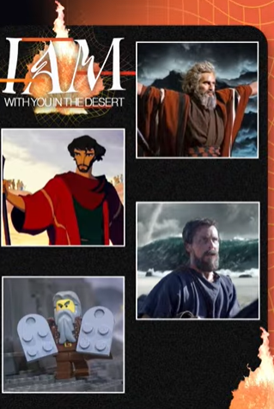

God With you in the desert

The "desert" is a powerful biblical metaphor for seasons of testing, isolation, and spiritual dryness where God’s presence becomes a lifeline rather than a luxury. Even in the most barren places, you are not alone; God uses these seasons to refine your faith and reveal His sufficiency.

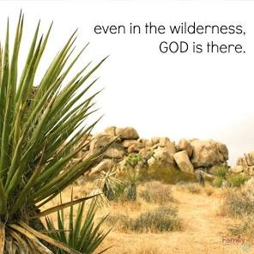 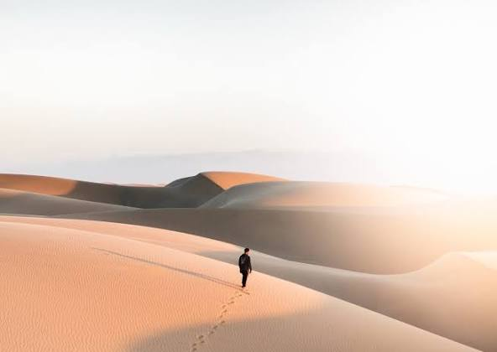

**How God Meets You in the Desert**

* **A Place of Divine Encounter**: In Hebrew, the word for desert (**midbar**) shares a root with the word for speaking (**medaber**). It is often in the silence of the wilderness that God’s voice becomes clearest.
* **Provision in Scarcity**: Just as He provided manna and water from a rock for the Israelites, He promises to "make a way in the wilderness and rivers in the desert" for you (Isaiah 43:19).
* **Refinement and Growth**: Desert seasons are often a prerequisite for a "new level" of purpose. Jesus was led into the desert by the Spirit before starting His ministry to demonstrate that "man does not live by bread alone".
* **Intimacy Over Comfort**: Being "stripped" of self-sufficiency in the desert forces an intimacy with God that is hard to find in times of plenty.

**Strategies for the Desert Season**

1. **Seek Him Earnestly**: Follow the example of **David** in Psalm 63, who sought God "in a dry and weary land where there is no water".
2. **Depend on the Word**: Use Scripture as a "lamp" when your path feels obscured by the shifting sands of your circumstances.
3. **Worship Through It**: Don't wait for the miracle to praise Him; worship is a weapon that shifts your focus from the barrenness to the Provider.

If you'd like, I can share **specific Bible verses** for encouragement or help you explore the **stories of biblical figures** who found their breakthrough in the wilderness.

The desert is the most barren place. God uses desert to refine your faith.

29:00/1:15:02

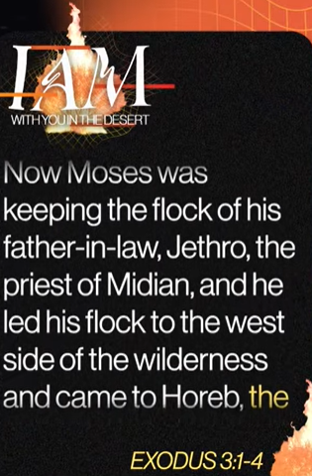 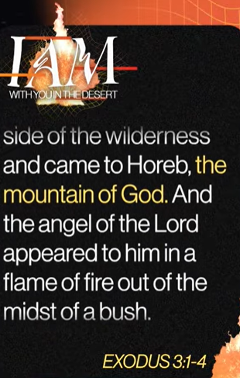 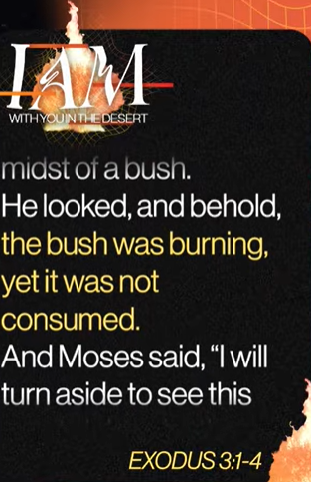

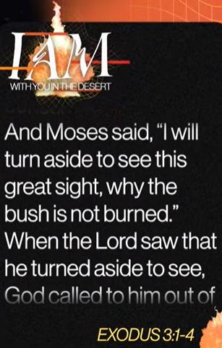 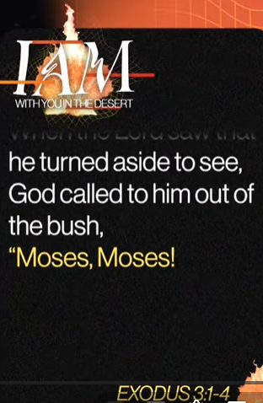

32:00/1:15:02

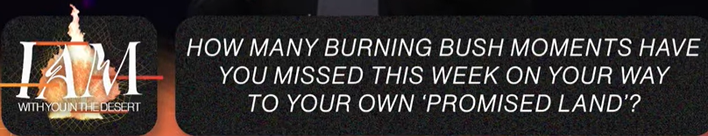

33:00/1:15:02

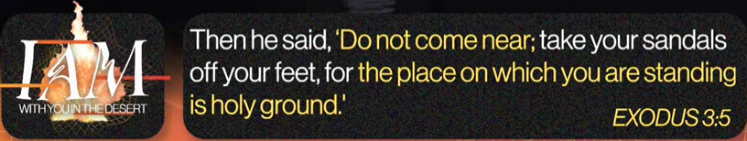

34:00/1:15:02

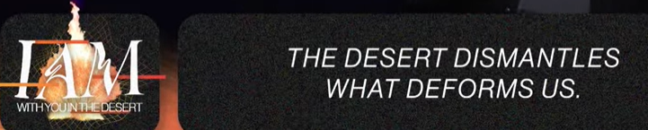

36:00/1:15:02

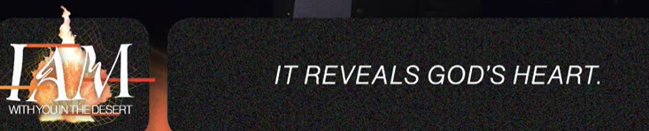

36:19/1:15:02

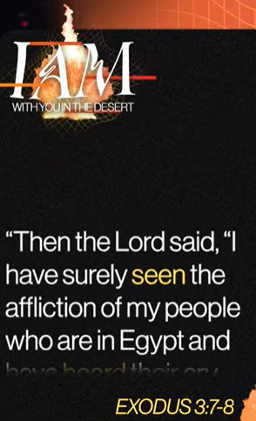 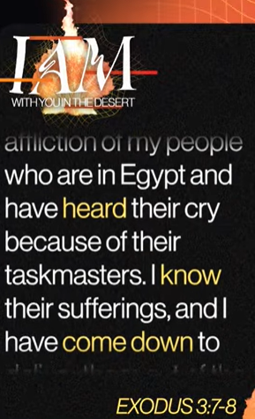 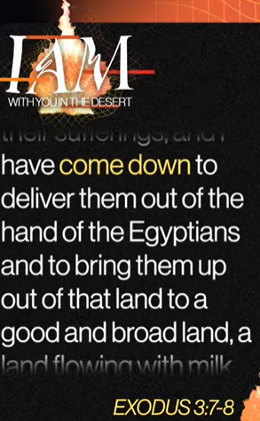

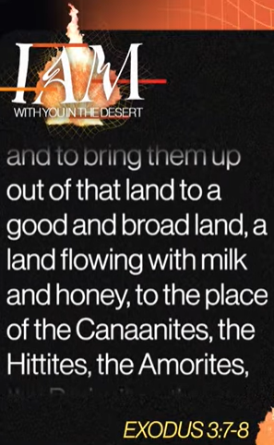 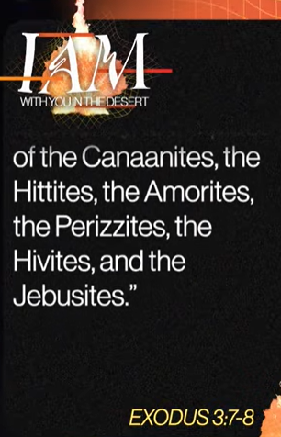

40:00/1:15:02

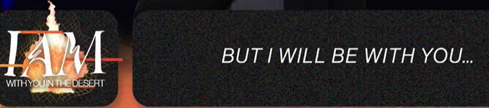

42:00/1:15:02

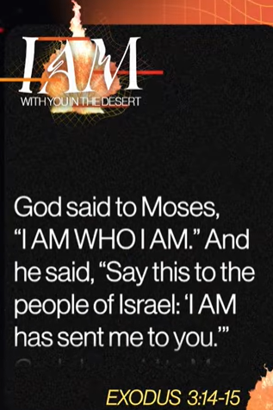 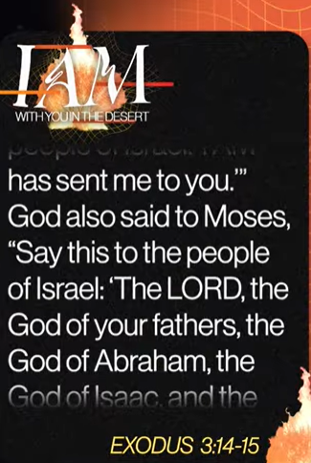

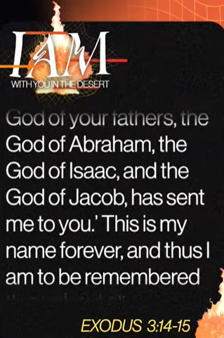 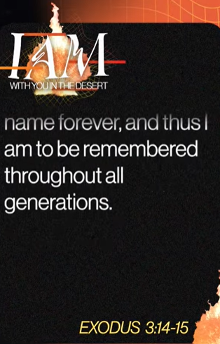

45:00/1:15:02

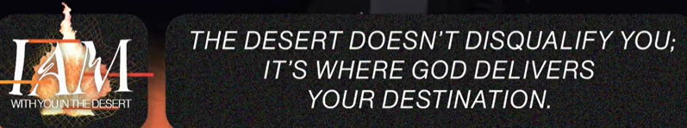

02/28/2026, Menlo Church Worship, Legacy (last week)

https://www.youtube.com/live/EYP2zTQK3QE?si=L1iGmo0BEvQpljhN

“I Am With You in the Desert | I Am: The God Who Gets Close,” Phil EuBank, Lead Pastor

Summary

1. The God Who Gets Close: God is a distant creator with personal/loving presence.

2. God With you in the desert: The desert is the most barren place for God to refine your faith.